Ex.No:16 | NMAP TO DISCOVER LIVE HOSTS USING ARP, ICMP, TCP AND UDP PING SCANS IN TRYHACKME
DATE:

Aim
To discover live hosts in a network using Nmap by performing ARP scan, ICMP scan, TCP ping scan, and UDP ping scan through a free TryHackMe learning environment.

Software Requirements
  - Computer or laptop with an internet connection
  - Web browser
  - Free TryHackMe account
  - A free-access lab room with an authorized target
  - Nmap terminal in the AttackBox or an authorized lab machine

Procedure
Step 1: Create a free TryHackMe account
Open https://tryhackme.com in a web browser. Select Sign Up, register using an available sign-in method, and log in to the account.

Step 2: Select a free room
Visit https://tryhackme.com/module/nmap and look for a room or activity related to Nmap and host discovery. Confirm that it is available under the free plan. If the relevant activity requires a subscription, choose another free room that provides a suitable authorized lab target. The learning-path catalogue is available at https://tryhackme.com/paths.

Step 3: Start the lab environment
Open the selected room, read its instructions, and start the target machine. Start the browser-based AttackBox if it is included in the available plan. Note the target IP address shown by the room and open the terminal. If using a local terminal, ensure it can reach the authorized lab target.

Step 4: Verify Nmap installation
Enter the following command in the terminal:

nmap --version

Step 5: Perform ARP scan
Command:
sudo nmap -PR -sn TARGET_IP
Explanation:
- -PR: Uses ARP requests for host discovery.
- -sn: Discovers hosts without performing a port scan.
- TARGET_IP: Replace this placeholder with the IP address of the authorized lab target.
Observation: Record whether Nmap identifies the target as up. ARP discovery generally applies to the same local network segment.

Step 6: Perform ICMP scan
Command:
sudo nmap -PE -sn TARGET_IP
Explanation: -PE sends ICMP Echo Request probes. The -sn option performs host discovery without port scanning.
Observation: Record whether Nmap reports “Host is up”. A firewall may block ICMP requests even when a host is active.

Step 7: Perform TCP ping scan
Command:
sudo nmap -PS80,443 -sn TARGET_IP
Explanation: -PS sends TCP SYN probes to ports 80 and 443. The -sn option disables port scanning.
Observation: Record whether Nmap detects the target as reachable. The result depends on target configuration and firewall rules.

Step 8: Perform UDP ping scan
Command:
sudo nmap -PU53,123 -sn TARGET_IP
Explanation: -PU sends UDP host-discovery probes to ports 53 and 123. The -sn option performs host discovery without port scanning.
Observation: Record the actual output. UDP probes may receive no response even when the target is active.

Observation Table
S. No. | Scan Technique | Nmap Option | Observed Result
1 | ARP scan | -PR
2 | ICMP scan | -PE
3 | TCP SYN ping | -PS

4 | UDP ping | -PU

Expected observation table
S.  No. | Scan technique | Command option | Expected observation
1 | ARP scan | -PR | Host detected on the same local network
2 | ICMP scan | -PE | Host detected if ICMP response is received
3 | TCP SYN ping | -PS | Host detected if a suitable TCP response is received
4 | UDP ping | -PU | Host detected if a suitable response is received

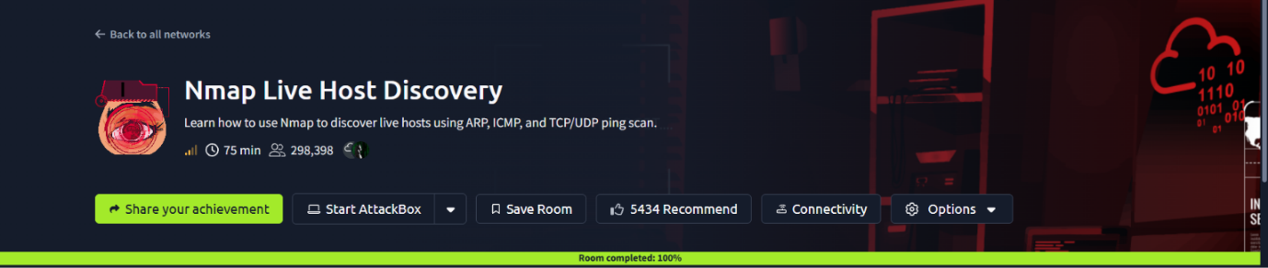
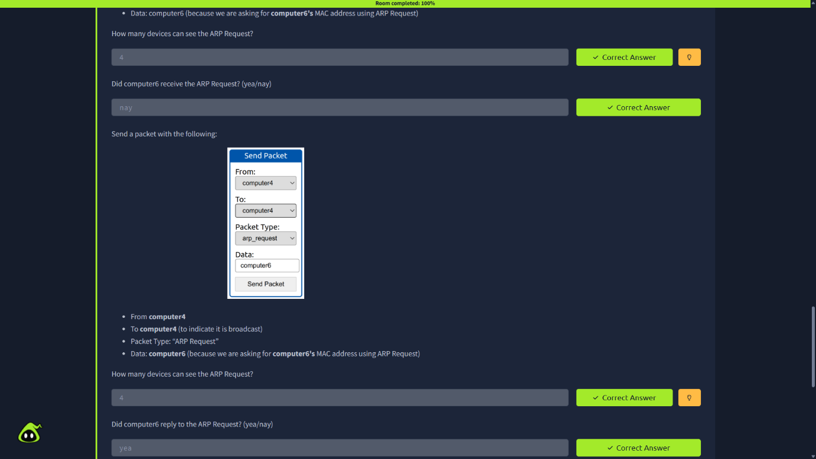

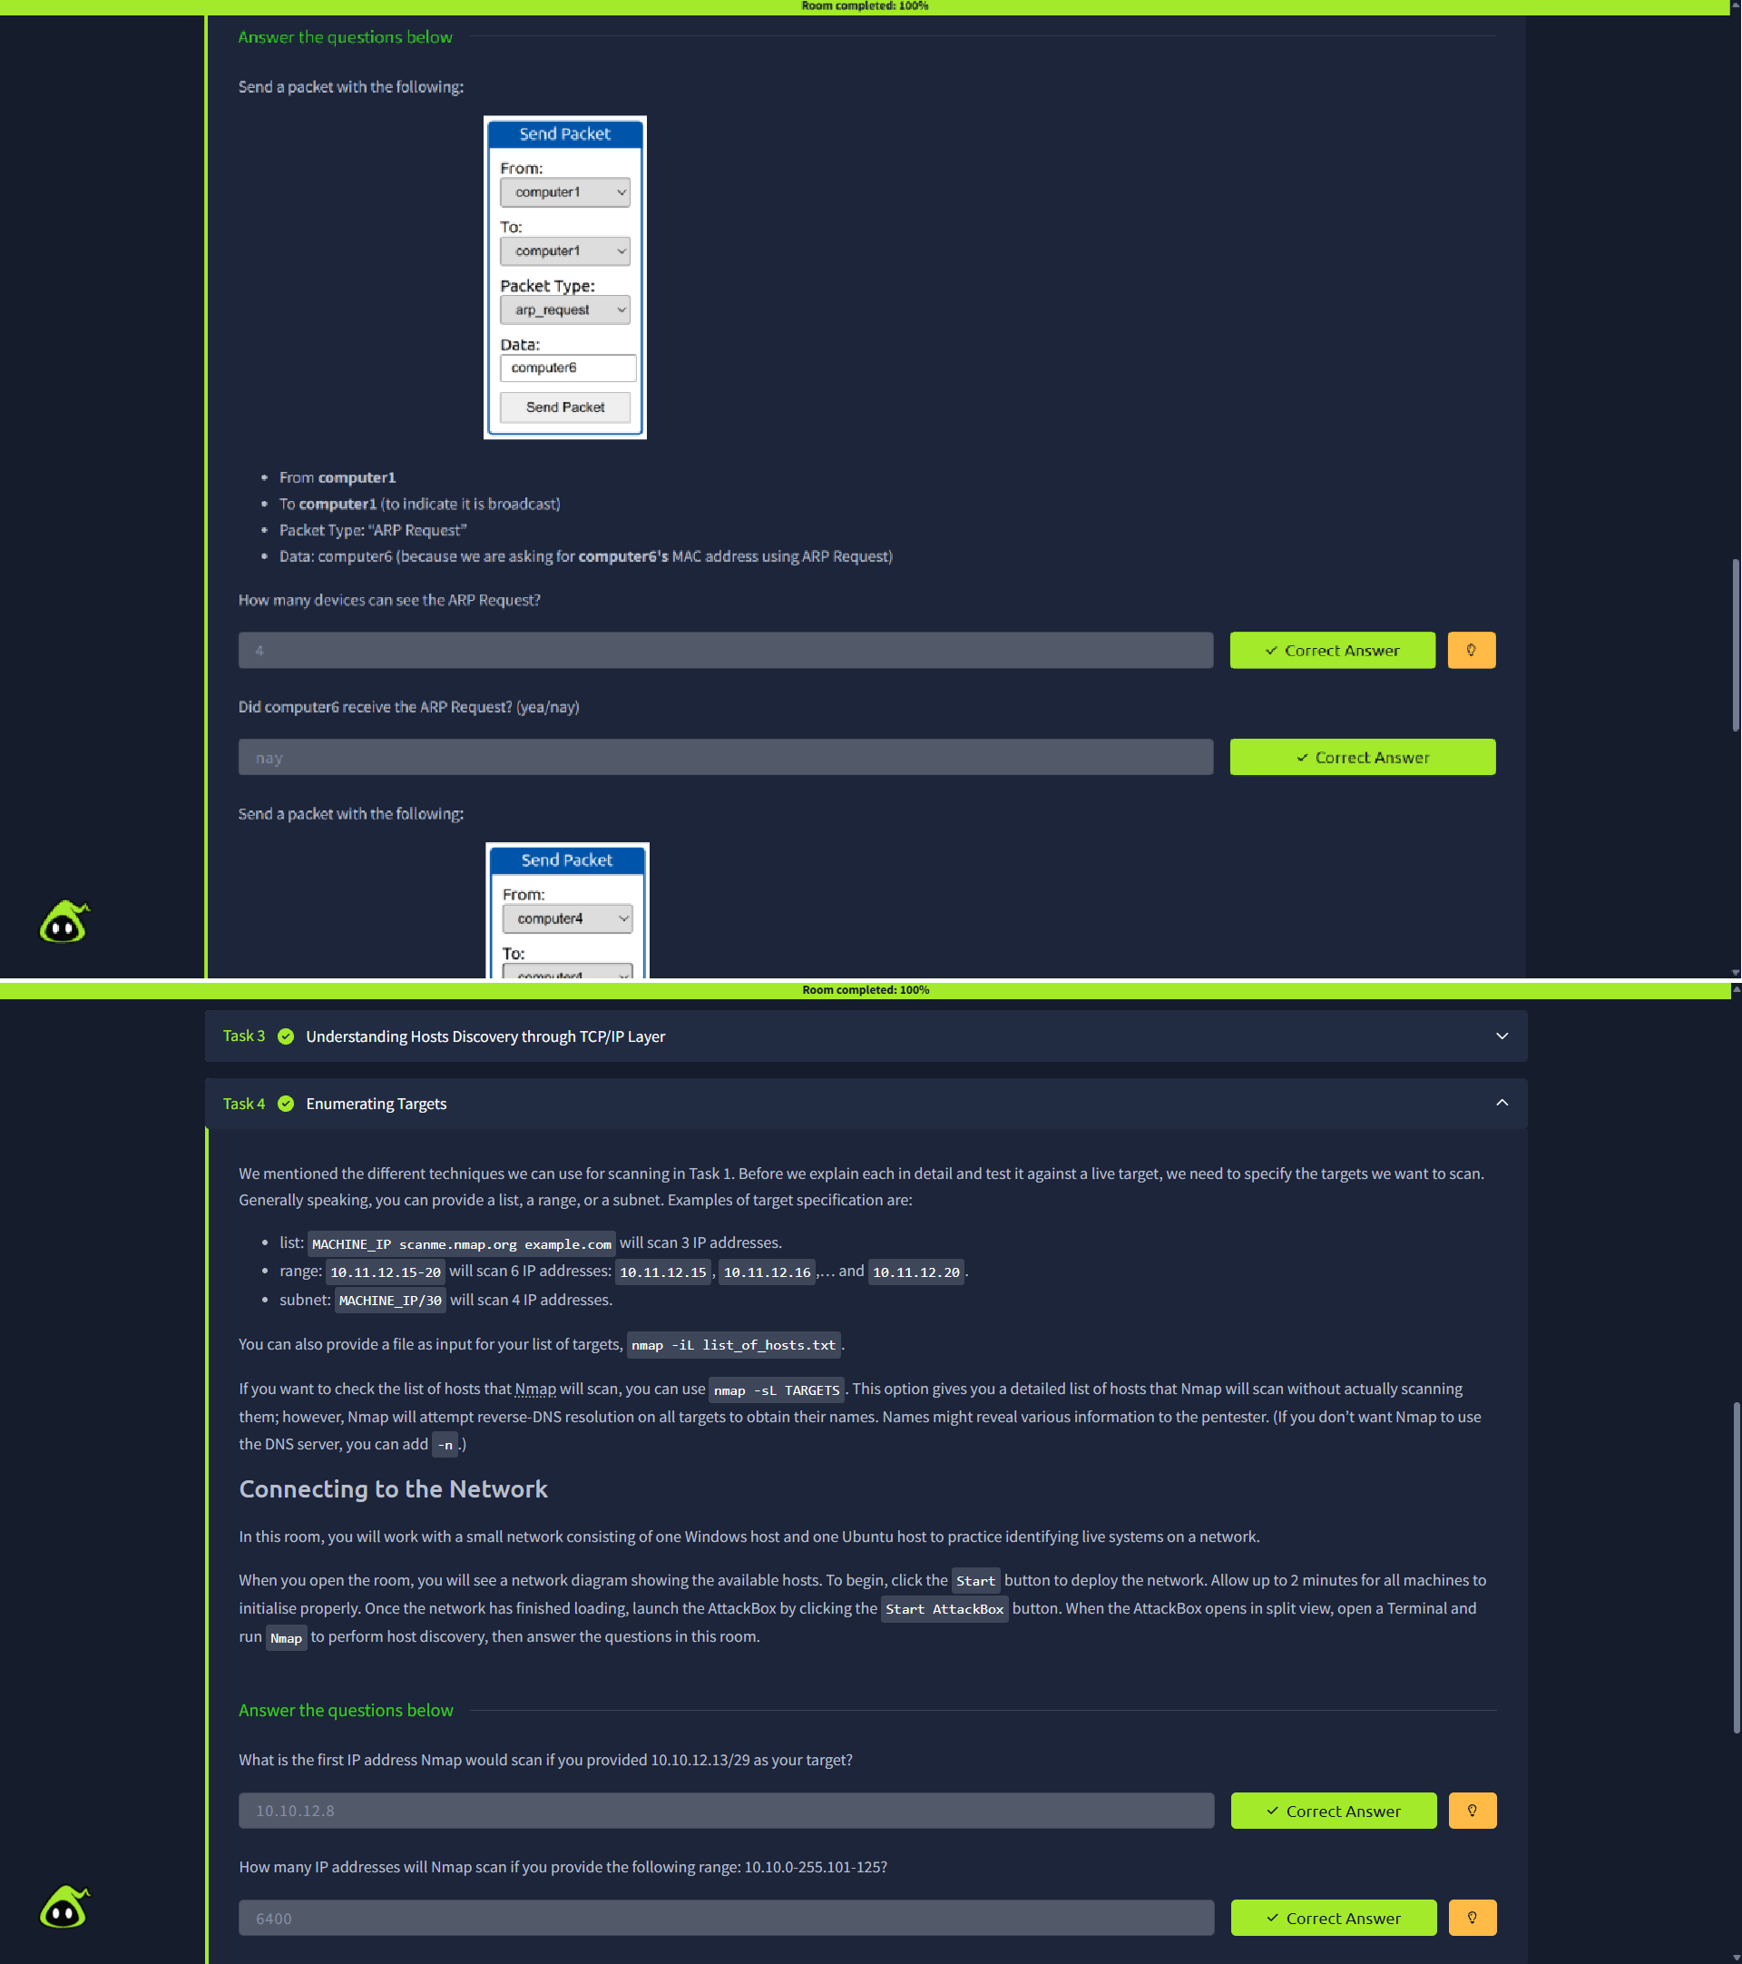

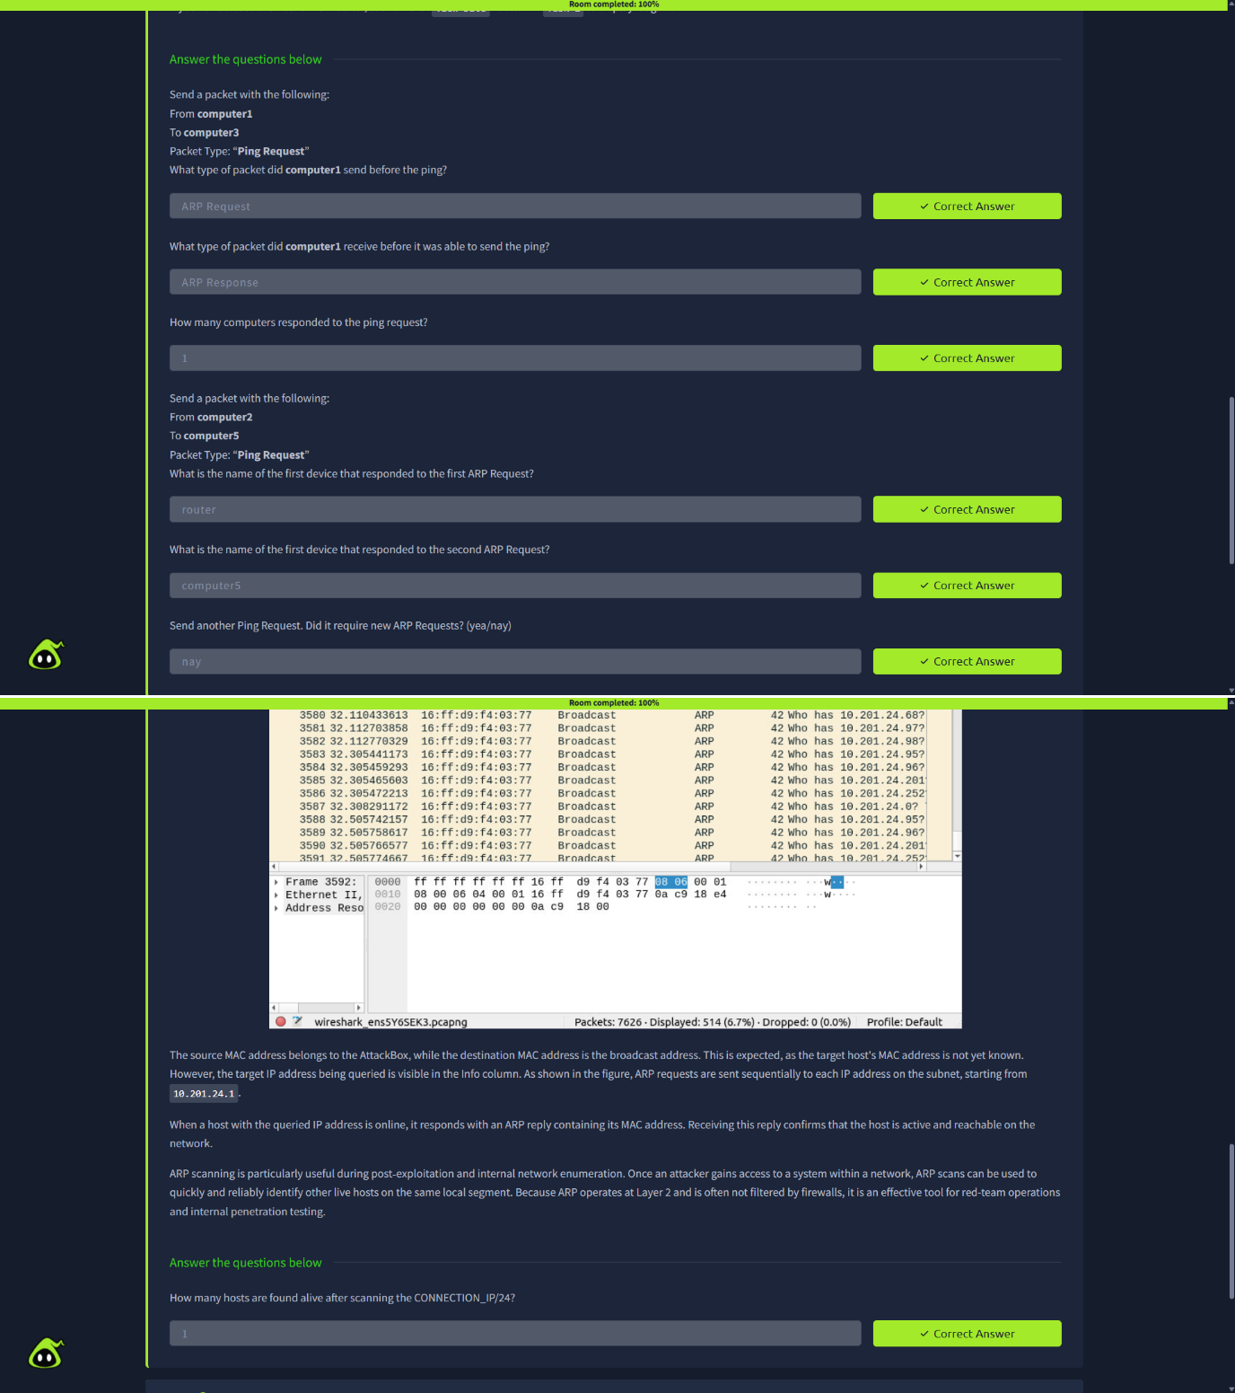

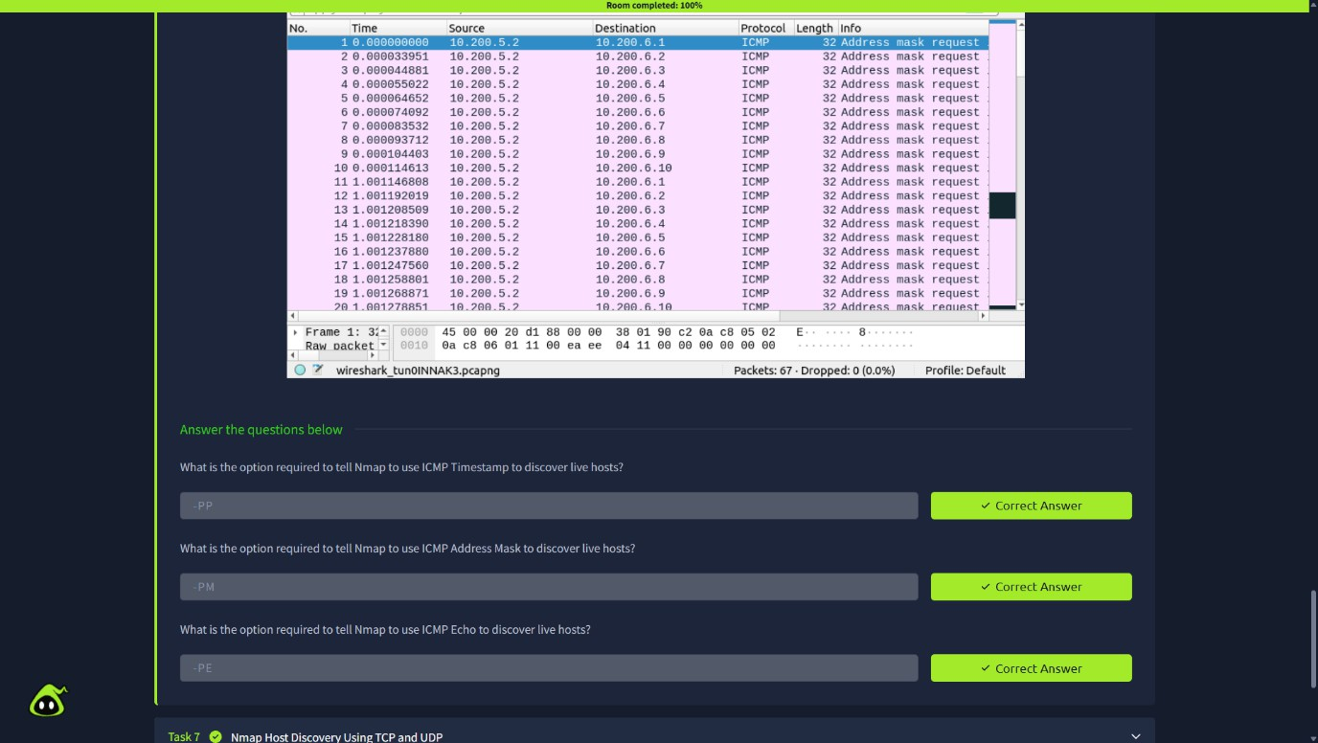

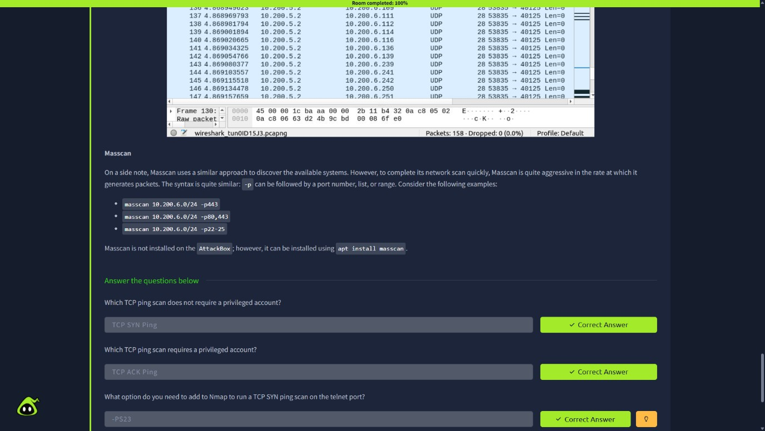

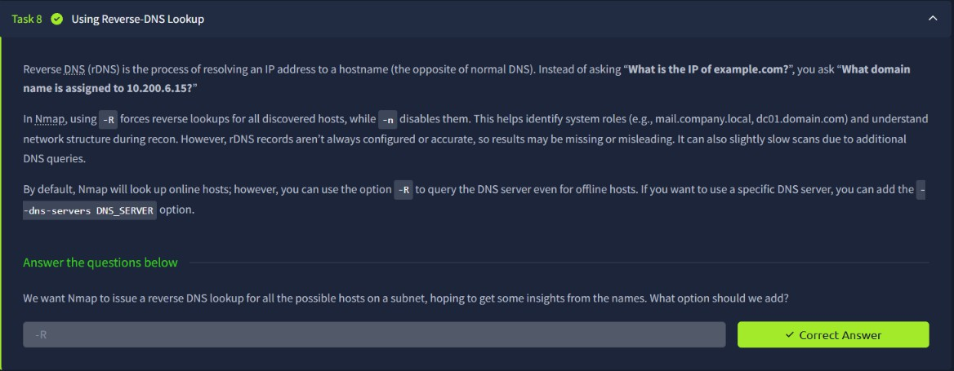

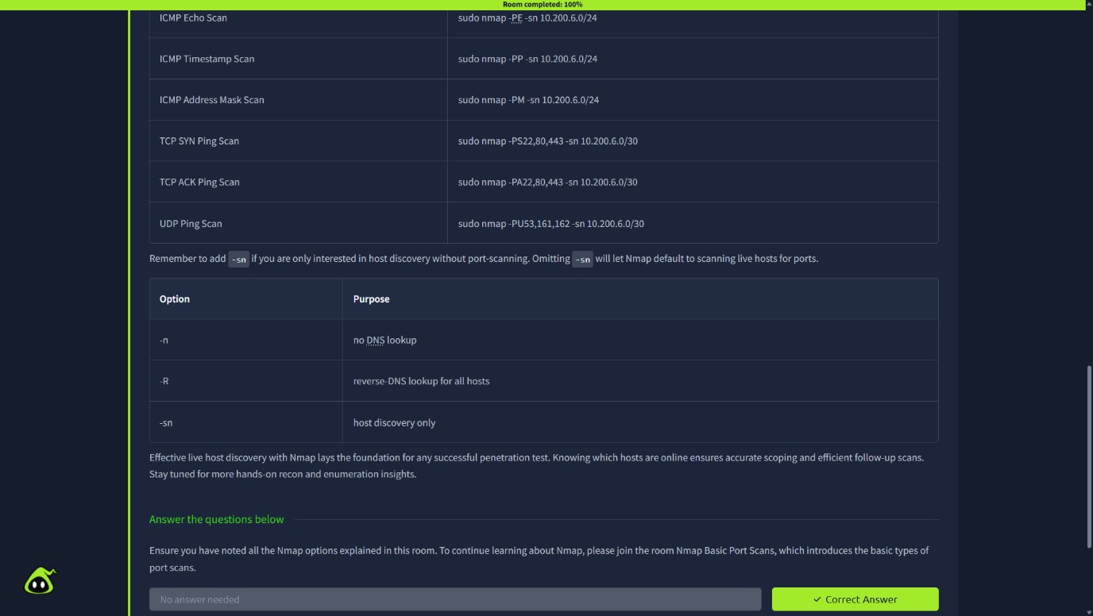

Result
Live host discovery was studied using Nmap in the TryHackMe learning environment. ARP, ICMP, TCP, and UDP probes were used to examine host reachability, and the observations were recorded.

Conclusion
Nmap provides multiple techniques for discovering active hosts. The effectiveness of each technique depends on network topology, target configuration, and firewall rules.

